Lab Exercises/Examples –WPF

Purpose: The purpose of this Lab work is to:
- Become familiar with Visual Studio .NET 2015 IDE
- Design and create simple apps which demonstrate use of WPF

References:
- Power Point slides/Study Notes and course material posted in drop box

Lab Programming Exercise #1:

Write a C# .NET WPF application that will keep track of student information.

The user will enter full name, address, city, province, postal code, phone number in text box controls.

B) The student’s major (Computer Programmer/Analyst or Computer Programmer) will be selected from two option radio buttons.

C) Two combo boxes will provide the lists of courses for each program. When user selects the desired program, display the corresponding combo box with the list of courses for that program.

D) List of courses for Computer Programmer/Analyst: Advance Programming, Computer Fundamentals and Software Engineering and List of courses for Computer Programmer: CSharp, Java and Web Programming.

E) A course will be added to a list box control named lstCourses whenever the user selects a course from the corresponding combo box control. Make sure that the user cannot add a course several times.

F) All the information about the student will be displayed in a multiline text box named txtDisplay. Display only Name (first name and last name together), Address and Courses selected from combo boxes.

Use GroupBox control to group similar controls as shown in the screen shot. Use Multiline property to display multiple lines of text in txtDisplay text box. Align the controls in order to design a neat and user friendly interface.

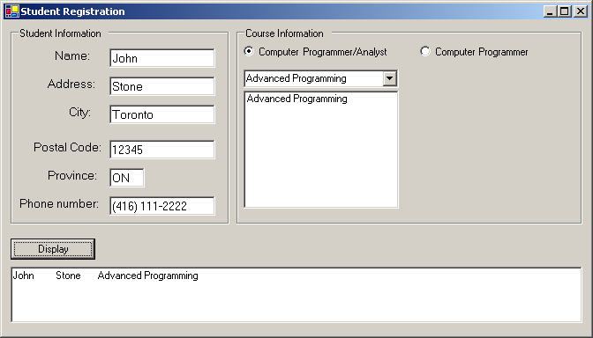

Provide the titles for the data that will be displayed in the text box.
Lab Programming Exercise #2:
Following example ( Painter – solution ) is demonstrated in the lab, you need to update this and add the following control and implement functionality:
#1. In Color group box, add a radio button –for Green
#2. In the Size group box, add a radio button – Large
#3. Add a button Exit below the Clear button.

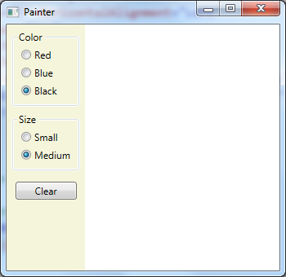
Lab Programming Exercise #3:
Write a C# .NET WPF application as shown below. This is your Lab 06 in Windows Forms, re-do it as WPF application.

